LEVELS OF COLLABORATION WORKSHEET

Directions:

1. Review the five levels of collaboration by reading the first, second, and third columns in the chart on the next page.
2. Think about the level of collaboration your program has with each of its partners. Fill in the fourth column.
3. Discuss with your colleagues which partnerships you would like to move to the next level of collaboration. How might moving to the next level of collaboration with each partner increase your impact and program’s sustainability?
4. For the partners that you selected in Step 3 above, indicate in column 5 what you could say or do to move each partnership to the next higher level of collaboration.

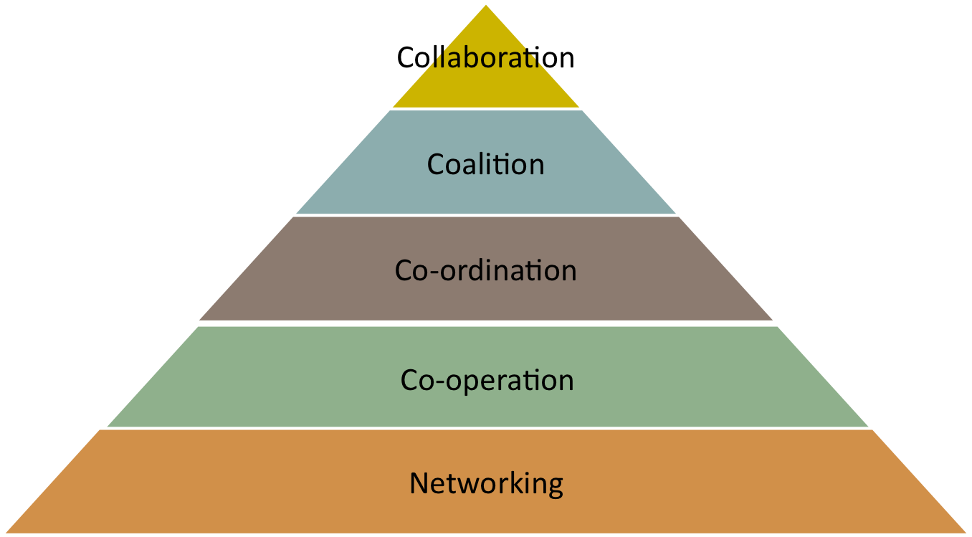

**Developing Partnerships: Levels of Collaboration[1]**

|  |  |  |  |  |
| --- | --- | --- | --- | --- |
| **Levels** | **Purpose** | **Structure and Process** | **Program Partnerships at this Level** | **What Could You Do to Move This Collaboration to the Next Level?** |
| *Level 1:*  *Networking* | Share information | Loose, flexible, nonhierarchical  Little conflict, informal communication  All decisions are made independently |  |  |
| *Level 2:*  *Alliance/Cooperation* | Limit duplication of services | Somewhat defined roles  Formal communication, agreements  Joint planning meetings, referrals  Most decisions are made independently |  |  |
| *Level 3:*  *Partnership/Coordination* | Share resources | Share information and resources  Defined roles, formal agreements  Frequent communication  Some shared decision making |  |  |
| *Level 4:*  *Coalition* | Share ideas and resources | Share ideas and resources  Dedicated staff time/funds  Frequent and prioritized communication  All members share decision making |  |  |
| *Level 5:*  *Collaboration and integration* | Build interdependent system to address common goals | Members belong to one system  Formal roles, joint staff trainings  Frequent communication is characterized by mutual trust  Consensus is reached on all decisions |  |  |

1. Adapted from: Frey, B.B., Lohneier, H.H., Lee, S. W., & Tollefson, N. (2006). Measuring collaboration among grant partners. *American Journal of Evaluation*, 27, 3, 383-392.